Use-Case Realization Report (Requirements)
Security Management

Issue 1.0
Revision History
Date | Issue | Description | Author

Table of Contents
1. Brief Description 4
2. Flow of Events 4
2.1 Standard Flow 4
2.1.1 Log-In 4
2.1.2 Change Password 4
2.1.3 Log-Out 4
2.1.4 Request for New Password 5
1. The User clicks ‘Forgot the Password’ link and the system is redirected to PersonalSecurityScreen. 5
2.2 Exceptions 5
3. Interaction Diagrams 5
3.1 Domain Collaboration Diagram: Security Management 5
4. Participating Objects 5
5. Derived Requirements 5

Use-Case Realization Report
Security Management

Brief Description
The use case describes the security management of VMS system. Registered user can login/logout the system. Meanwhile, User is able to make changes to password after login. And registered User also can request for a new password when he/she forgets the old password.

Flow of Events
The standard flow of events for this use case and any exceptions are described in the following subsections. See section 3.1 for an overview of the participating Actors and Domain Objects.

Standard Flow
This use case provides the user interface related functionality that will be provided to the User, as follows:

Log-In
To commence using the system functions, the User is required to log-in as follows:
- The User clicks ‘Login’ link and the system is redirected to PersonalSecurityScreen.
- The User is required to enter a valid password into the Login Screen.
- The system will check that the entered password is valid.
- If the password is invalid then the caption “Invalid Password” will be highlighted on the Login Panel.
- If the password is valid (ie: the User has successfully logged-in), then the following will occur:
a) For Volunteer,
- The system will be redirected to VolunteerMainScreen.
- User can view detailed project info including Calendar and Itinerary
- User can edit/post stories
- User can submit feedback
- User can update Personal profile
- For System Staff
- The system will be redirected to StaffMainScreen
- The staff can perform role-based operations
- The staff can update Personal profile

Change Password
If the User logs-in successfully, he/she is able to update his/her password as follows:
- The User click ‘Change Password’ link and the system is redirected to PersonalSecurityScreen.
- The system will prompt the user to enter the old password
- The System will prompt the user to enter the new password.
- The system will validate the new password. If the new password conform to predefined security format, system will prompt that ‘Password change Success’

Log-Out
- The User may log out of the System by clicking the ‘log out’ link.
- The system is redirected to VisitorMainScreen
- After User logout,
  - Session information will be removed from the system.
  - User is unable to browse system detailed information
  - User is unable to perform any system operations.

Request for New Password
- The User clicks ‘Forgot the Password’ link and the system is redirected to PersonalSecurityScreen.
- User will be prompted to enter email address
- If the email address is registered, system will prompt the predefined security question
- User enters answer to the security question.
- If the answer is valid, a new password will be generated by the system and sent to user via email address.
- System will prompt ‘New password Generated and sent to your email’

Exceptions
The following exceptions have been identified:
- Invalid Password . If User still failed to enter the correct password after ten attempts. The user account will be locked.
- Invalid New Password. If the new password doesn’t conform to the security format, system will prompt the format tips to assist users
- Invalid email address. If the email address is not registered, system will prompt error message

Interaction Diagrams

Domain Collaboration Diagram: Security Management

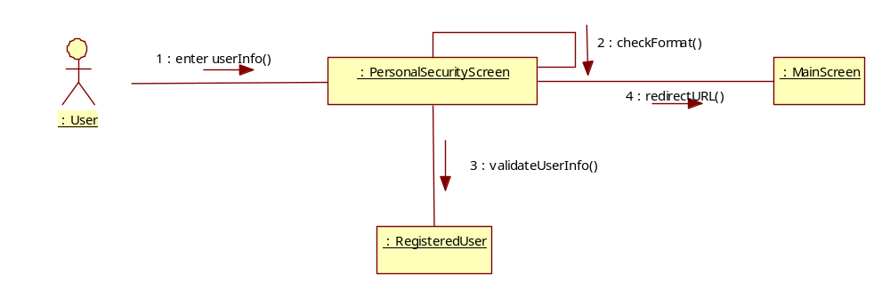

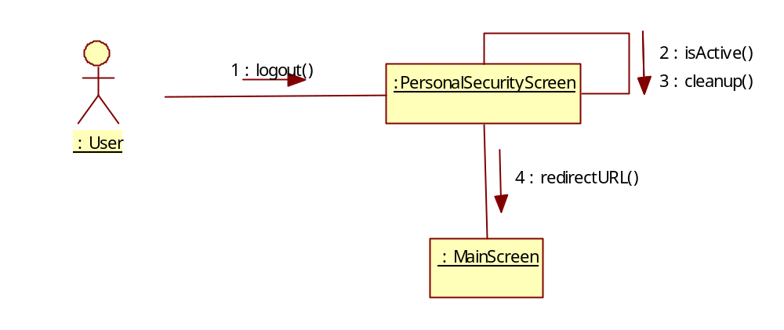

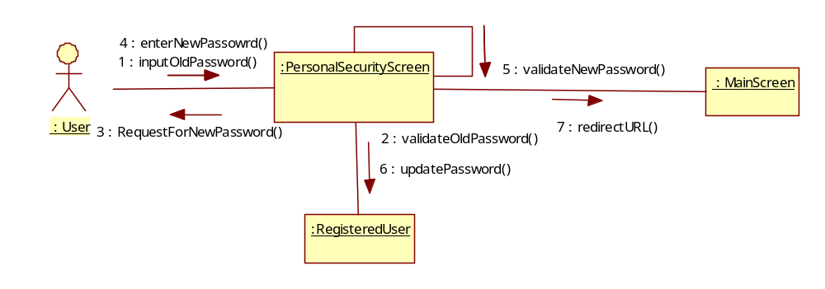

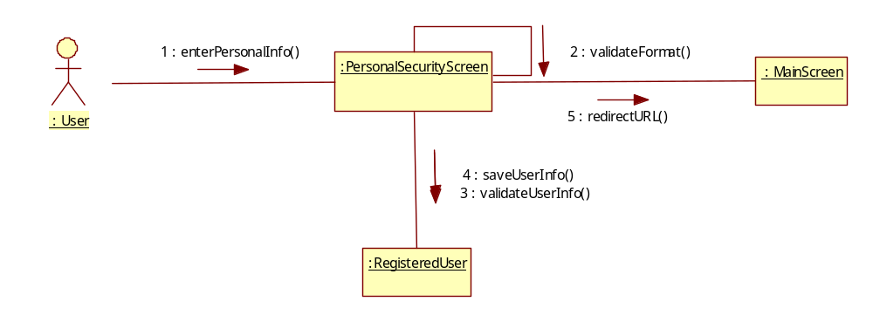

Participating Objects
:

Derived Requirements

